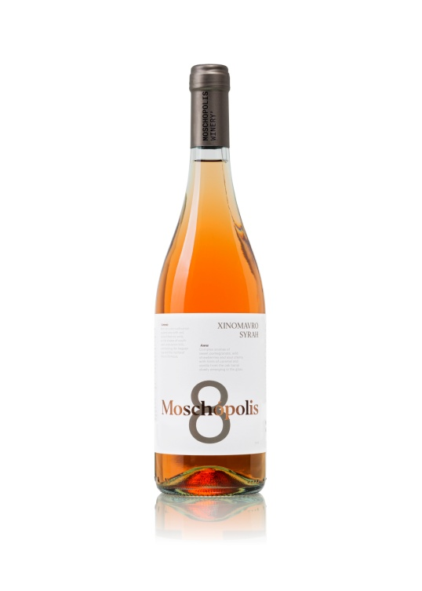

Moschopolis 8 2023 Wine Tech Sheet

**Name of the wine:** Moschopolis 8 Xinomavro Syrah 2022, *Thessaloniki Greece.*

**Grape variety or blend:** *Xinomavro 80 % Syrah 20%*

**Harvest dates:** *15 to 30 of September*

**Vineyard location:** Mesimeri Thessaloniki

**Vineyard elevation:** 150

**Vineyard size:** *1.5 hectares*

**Yields*:*** *30 to 40 hectolitres per hectare*

**Age of vines: 14 years**

**Trellising:** *Guyot*

**Dry farming**

**Farming practices:** *Organic*

Moschopolis 8 2023 Wine Tech Sheet

**Hand vs. machine harvesting:** Hand

**Pressing:** Whole cluster. *Horizontal screw press*

**Yeast type:** *Native*

**Pre and post-fermentation maceration:** Pre-fermentation *maceration for12 hours at 10oC.*

**Fermentation vessel:** *Stainless steel, Oak barrels*

**Length of primary fermentation:** *Slow fermentation 7-14 days at 17oC*

**Malolactic fermentation/conversion:** *Yes*

**Lees contact:** *8 months with battonage*

**Ageing and****time in wood (or tank):** *6 months in oak barrels*

**Vessel:** *225lt second-third hand French oak*

**Fining:** *Usually unfined, occasionally bentonite and small percentage of gum Arabic*

**Filtration:** *Unfiltered*

**Bottle age:** None

**Total and/ or free S02:** 66/16 (Total SO2 Always <100)

**Closure type:** *Natural DIAM*

**ABV:** 12.5 %

**Residual sugar:** *in grams per litre (2.3g/lt)*

**TA (total acidity) and pH:** 6.3 / 3.27