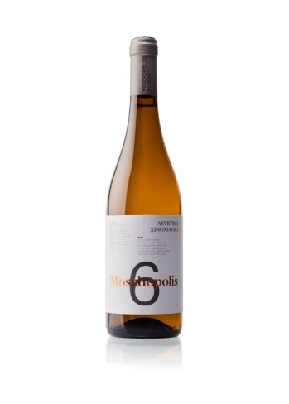

Moschopolis 6 2023 Wine Tech Sheet

**Name of the wine:** Moschopolis 6 Assyrtiko with a touch of Xinomavro

**Type:** White Varietal Wine

**Retail price:** 18 € **Bottles produced:** 8700.

**Grape variety or blend:** Assyrtiko 93% *Xinomavro 7 %*

**Harvest dates:** *1 to 15 of October.*

**Vineyard location:** Mesimeri and Monopigado Thessaloniki

**Vineyard elevation:** 150 - *500m*

**Vineyard size:** *2.5 hectares*

**Yields*:*** *30 to 40 hectolitres per hectare*

**Age of vines:** 5 -15 years

**Trellising:** *Guyot and Geneva Double Curtain*

**Dry farming**

Moschopolis 6 2023 Wine Tech Sheet

**Farming practices:** *Organic, Regenerative*

**Hand vs. machine harvesting:** Hand

**Pressing: Whole cluster.** *Horizontal screw press*

**Yeast type:** *Native*

**Pre and post-fermentation maceration:** Pre-fermentation *maceration for12 hours at 10oC.*

**Fermentation vessel:** *Stainless steel, Oak barrels*

**Length of primary fermentation:** *Slow fermentation 7-14 days at 17oC*

**Malolactic fermentation/conversion:** *yes*

**Lees contact:** *6 months with battonage*

**Ageing and****time in wood (or tank):** *6 months in oak barrels*

**Vessel:** *225lt and 500lt new and second-hand French oak*

**Fining:** *Usually unfined, occasionally bentonite and small percentage of gum Arabic*

**Filtration:** *Unfiltered*

**Bottle age: None**

**Total and/ or free S02:** 76/24 (Total SO2 Always <100)

**Closure type:** *Natural DIAM*

**ABV:** 13.5 %

**Residual sugar:** *in grams per litre (2.8g/lt)*

**TA (total acidity) and pH:** 6.1 / 3.11