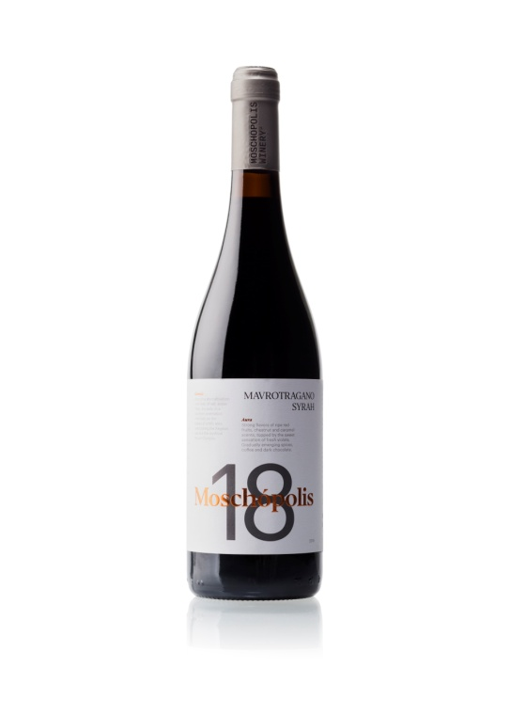

Moschopolis 18 2021 Wine Tech Sheet

**Name of the wine:** Moschopolis 18 Mavrotragano Syrah 2021, *Thessaloniki Greece.*

**Grape variety or blend:** Mavrotragano 60 – Syrah 40%

**Harvest dates:** *5 to 20 of September*

**Vineyard location:** Monopigado Thessaloniki

**Vineyard elevation:** *500m*

**Vineyard size:** *2 hectares*

**Yields*:*** *25- 30 hectolitres per hectare*

**Age of vines:** 24 years

**Trellising:** *Guyot*

**Dry farming**

**Farming practices:** *Organic*

Moschopolis 18 2020 Wine Tech Sheet

**Hand vs. machine harvesting:** Hand

**Pressing:** *Horizontal screw press*

**Yeast type:** *Native*

**Pre and post-fermentation maceration:** post-fermentation *maceration for15-20 days at 23oC.*

**Fermentation vessel:** *Stainless steels*

**Length of primary fermentation:** *Slow fermentation 7-12 days at 19oC*

**Malolactic fermentation/conversion:** *Yes*

**Lees contact:** *None*

**Ageing and****time in wood (or tank):** *18 months in oak barrels*

**Vessel:** *225lt second-third hand French oak*

**Fining:** *Usually unfined, occasionally a small percentage of gum Arabic*

**Filtration:** *Unfiltered*

**Bottle age:** None

**Total and/ or free S02:** 76/19 (Total SO2 Always <100)

**Closure type:** *Natural DIAM*

**ABV:** 15 %

**Residual sugar:** *in grams per litre (2.8g/lt)*

**TA (total acidity) and pH:** 5.6 / 3.37