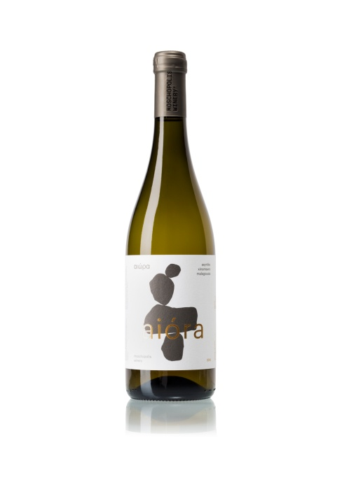

Aiora White 2023 Wine Tech Sheet

**Name of the wine:** Aiora Assyrtiko Xinomavro Malagousia Amphora 2023, *Thessaloniki Greece, Varietal.*

**Grape variety or blend:** Assyrtiko 45 % Xinomavro 20 % *Malagousia 35 %*

**Harvest dates:** *25 of August to 10 of September*

**Vineyard location:** Mesimeri Thessaloniki

**Vineyard elevation:** *150m*

**Vineyard size:** *2.2 hectares*

**Yields*:*** *30 to 40 hectolitres per hectare*

**Age of vines:** 15 years

**Trellising:** *Guyot*

**Dry farming**

**Farming practices:** *Organic*

Aiora Malagousia Amphora 2023 Wine Tech Sheet

**Hand vs. machine harvesting:** Hand

**Pressing:** *Horizontal screw press*

**Yeast type:** *Native*

**Pre and post-fermentation maceration:** Pre *Maceration for 6 hours in low temperature.*

**Fermentation vessel:** Stainless steel and Traditional Cretan *amphora*

**Length of primary fermentation:** *Slow fermentation 7-14 days at 17oC in Stainless Steel tanks and Slow fermentation 30 days at natural temperatures 12 - 25oC in amphora*

**Malolactic fermentation/conversion:** *Yes*

**Lees contact:** *4 months with battonage*

**Ageing and****time in wood (or tank):**  *Partly aging for 5 months in amphorae*

**Vessel:** *Stainless steel and 300lt amphora*

**Fining:** *Unfined, occasionally bentonite and small percentage of gum Arabic*

**Filtration:** *Unfiltered*

**Bottle age: None**

**Total and/ or free S02:** 67/18 (Total SO2 Always < 100)

**Closure type:** *Natural DIAM*

**ABV:** 12.5 %

**Residual sugar:** *in grams per litre (2.0g/lt)*

**TA (total acidity) and pH:** 5.8 / 3.25