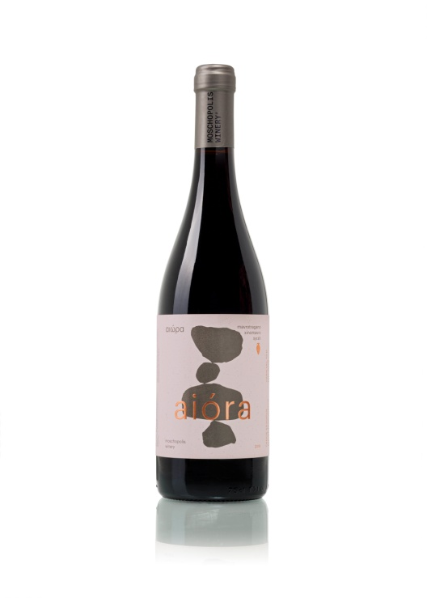

Aiora Red 2022 Wine Tech Sheet

**Name of the wine:** Aiora Mavrotragano Xinomavro Syrah 2022, *Thessaloniki Greece, Varietal.*

**Grape variety or blend:** *Mavrotragano 30% Xinomavro 40 % Syrah 30%*

**Harvest dates:** *25 of August to 10 of September*

**Vineyard location:** Mesimeri Thessaloniki

**Vineyard elevation:** *150m*

**Vineyard size:** *2.2 hectares*

**Yields*:*** *30 to 40 hectolitres per hectare*

**Age of vines:** 15 - 20 years

**Trellising:** *Guyot*

**Dry farming**

**Farming practices:** *Organic*

Aiora Red 2022 Wine Tech Sheet

**Hand vs. machine harvesting:** Hand

**Pressing: Partly** *Horizontal screw press*

**Yeast type:** *Native*

**Pre and post-fermentation maceration:** *Maceration for 7-8 days.*

**Fermentation vessel:** *Stainless steel, amphora*

**Length of primary fermentation:** *Slow fermentation 7-10 days at 17oC*

**Malolactic fermentation/conversion:** *Yes*

**Lees contact:** *No*

**Ageing and****time in wood (or tank):** *4-5 months in traditional Cretan amphorae*

**Vessel:** *stainless tank and 300lt amphora*

**Fining:** *Usually unfined, occasionally a small percentage of gum Arabic*

**Filtration:** *Unfiltered*

**Bottle age: None**

**Total and/ or free S02:** 36/9 (Total SO2 Always < 40) Natural

**Closure type:** *Natural DIAM*

**ABV: 13.5 %**

**Residual sugar:** *in grams per litre (< 2.5g/lt)*

**TA (total acidity) and pH:** 5.2 / 3.40