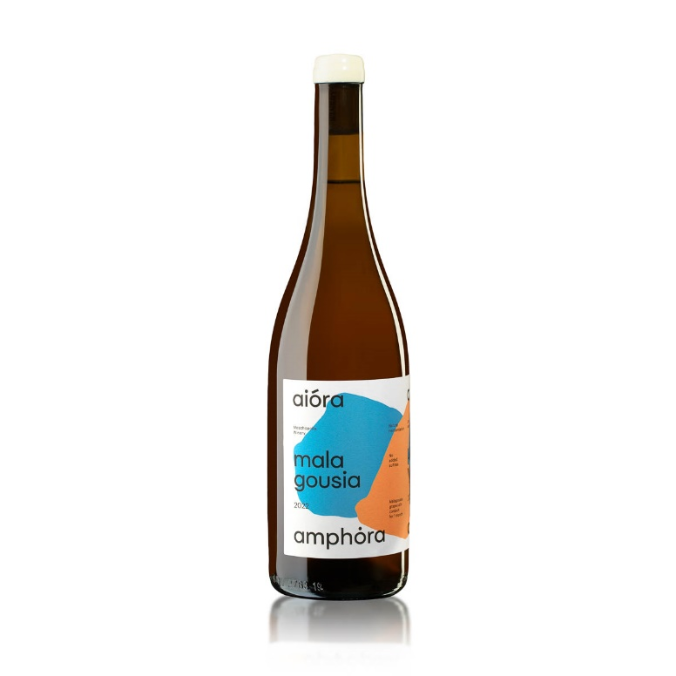
Aiora Malagousia Amphora 2023 Wine Tech Sheet

Name of the wine: Aiora Malagousia Amphora 2023, Thessaloniki Greece, Varietal.
Grape variety or blend: Malagousia 100%
Harvest dates: 25 of August to 10 of September
Vineyard location: Monopigado Thessaloniki
Vineyard elevation: 500m
Vineyard size: 1 hectare
Yields: 30 to 40 hectolitres per hectare
Age of vines: 15 - 20 years
Trellising: Geneva Double Curtain
Dry farming
Farming practices: Organic, Regenerative

Aiora Malagousia Amphora 2023 Wine Tech Sheet

Hand vs. machine harvesting: Hand
Pressing: Traditional vertical manual screw press
Yeast type: Native
Pre and post-fermentation maceration: Maceration for 15 days.
Fermentation vessel: Traditional Cretan amphora
Length of primary fermentation: Slow fermentation 30 days at natural temperatures 12 - 25oC
Malolactic fermentation/conversion: Yes
Lees contact: 5 months
Ageing and time in wood (or tank): 5 months in amphorae
Vessel: 300lt amphora
Fining: Unfined
Filtration: Unfiltered
Bottle age: None
Total and/ or free S02: 10/0 (Total SO2 Always < 40) Natural
Closure type: Natural DIAM
ABV: 13 %
Residual sugar: in grams per litre (2.4g/lt)
TA (total acidity) and pH: 5.4 / 3.40

